Message from your ACHE Regent

Fall 2024

As the 2024 year comes to a close, it is a great time to reflect on professional and personal accomplishments. If you are like me, the new year brings a fresh list of exciting opportunities for learning and new professional experiences. As healthcare professionals, it is critical for us to keep up to date on the ever-changing landscape. ACHE offers many resources to help us. I usually challenge myself to read at least three to four new books each year related to healthcare. Our Health Administration Press (HAP) offers a wide variety of books to choose from. Here are a few of my favorites from this year:

* [Mentor, Coach, Lead](https://www.ache.org/learning-center/publications/books/2485i)
* [Leadership in Healthcare](https://www.amazon.com/Leadership-Healthcare-Essential-Values-Management/dp/1567938469/ref=asc_df_1567938469?mcid=1718e6da591d34ef96e88d2aed33488c&tag=hyprod-20&linkCode=df0&hvadid=693377694383&hvpos=&hvnetw=g&hvrand=9449766376953642489&hvpone=&hvptwo=&hvqmt=&hvdev=c&hvdvcmdl=&hvlocint=&hvlocphy=9021712&hvtargid=pla-761469333792&psc=1)
* [Leading With Your Upper Brain](https://www.amazon.com/Leading-Your-Upper-Brain-Performance/dp/1640553274/ref=asc_df_1640553274?mcid=a7982638ab8537cd9bd44f96d3d00dc9&tag=hyprod-20&linkCode=df0&hvadid=693310352361&hvpos=&hvnetw=g&hvrand=9391374114497577621&hvpone=&hvptwo=&hvqmt=&hvdev=c&hvdvcmdl=&hvlocint=&hvlocphy=9021712&hvtargid=pla-1678607305391&psc=1)

I am looking forward to reading [FutureScan 2025: Healthcare Trends and Implications](https://www.ache.org/learning-center/publications/books/2527i) when it comes out in 2025. HAP is having a [Holiday Sale](https://www.ache.org/learning-center/publications) so now is the perfect time to start your professional growth reading list for 2025!

**HAP Holiday Sale | 20% Off**

HAP Holiday Sale - Order any book now through January 3, 2025, and receive a 20% discount off the member and non-member prices when you use **HOLIDAY24** at checkout. This discount excludes any multi-book sets and bundles that are already discounted and the ACHE Board of Governors Examination Flashcards.

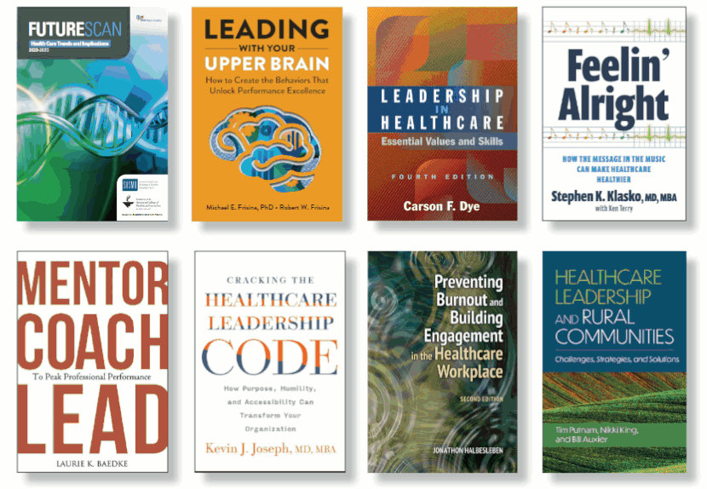

I recently had the honor of speaking to the MHA students at two of the HEN programs in our state.

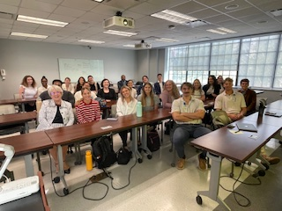

At MUSC, Dr. Zahi Jurdi, allowed me to hear several students present on a current healthcare topic. One student shared the impact of POC in an Ambulatory Environment and the other on AI and the future impact on healthcare. I very much enjoyed meeting this class of MHA students.

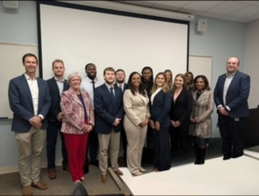

At USC, I was able to participate along with Brandon Hulko, Sue Haddock, Sabrina Robinson, FACHE and Nicole Woods, FACHE in mock Administrative Fellowship interviews with the MHA students. They all did an excellent job. Hats off the Dr. Abil Natafgi and Sandra Rhyne for a great visit with this class.

Lastly, I was honored to serve on an Executive Leadership panel at the 2024 LeadHERship Summit sponsored by National Organization, Women in Healthcare. The focus of this three-day meeting in Atlanta was Generation WE. What a great experience!

Welcome to all the new SC ACHE members to our organization. I encourage you to get involved with our state organization. The professional friendships and networking are priceless.

*Karen*

Karen G. Schwartz, FACHE

Regent for South Carolina

[karen_schwartz@bshsi.org](mailto:karen_schwartz@bshsi.org)