Message from your ACHE Regent
Fall 2023

As we enter the holiday season, my thoughts go to the concept of Gratitude. Melody Beattie states it best, “Gratitude makes sense of our past, brings peace for today and creates a vision for tomorrow.”

I am going to unpack that quote from a personal perspective first. Gratitude makes sense of our past – when I started my career in healthcare in the early 80s, achieving a Fellow Certification within the College was not on my professional radar. I had the privilege of working for a faith-based healthcare system in Greenville, SC that had three working Franciscan Sisters. One of them was Sister Bernardine. She was a force to be reckoned with – only standing 4’ 11” but with a quick mind and focus on quality and safety. I am honored to have worked with her, learned from her. My office in this same health care system is in the building named in her honor. I walk past her picture every day as well as the plaque from The American College of Hospital Administrators awarding her Fellowship status in the College in 1956 – four years before I was even born. I remain grateful for the opportunity to learn from this great leader.

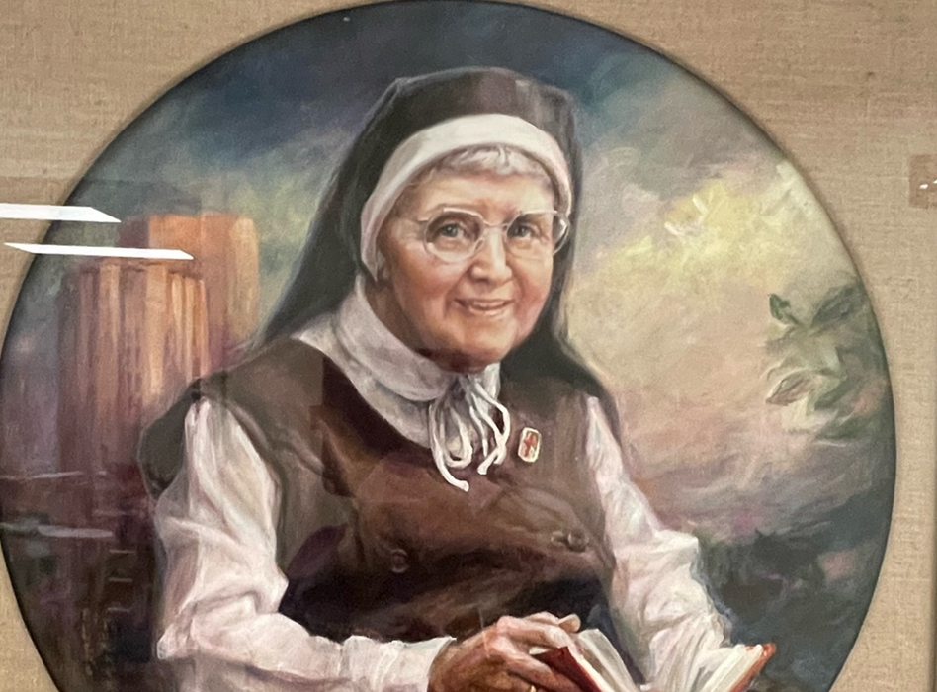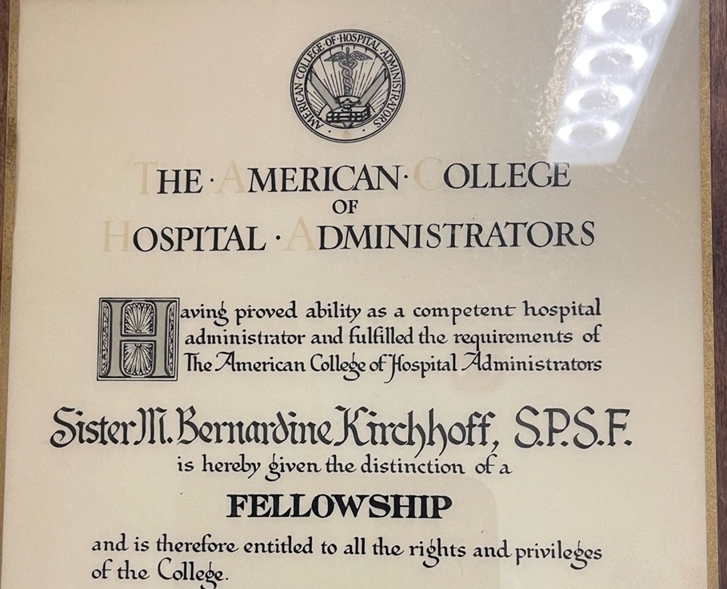

Gratitude brings peace for today! I am grateful for the five industry leaders who have chosen to be Premier Corporate Partners for ACHE. These leaders in healthcare provide valuable support for our organization’s vision to be the preeminent professional society for leaders dedicated to advancing health. They share in our Mission to advance our members and healthcare leadership excellence.

- Exact Sciences
- Intuitive
- Lean Taas
- Optum
- Quest Diagnostics

If any of these companies work with you in your daily work – send a note of gratitude for their contributions and support of ACHE.

Finally, Gratitude creates a vision for tomorrow. The brand statement you see on our ACHE website, BOLDER, BRIGHTER TOGETHER….. speaks to our Future! What better way to support our Future than to give to The Fund for Healthcare Leadership!

This fund provides scholarships for ACHE Members to gain skills and training that are needed to serve in the changing, dynamic healthcare management field. Our ACHE Chair and Chair-Elect have created the $1Million Campaign for Healthcare Leaders of Tomorrow. This campaign will fund Healthcare Leadership Scholarships for diversity programs like the Thomas C. Dolan Executive Scholarship program. Consider showing your gratitude for our future by donating to one of these funds over the holiday season.

Another gratitude I celebrate is our Higher Education Network members in South Carolina. I had the wonderful opportunity to meet and speak to the MHA students at three of our SC HEN’s this fall. The students at Medical University of South Carolina, University of South Carolina, and Winthrop University are an impressive group. We have much to look forward to with these bright, young upcoming professionals focused on healthcare leadership.

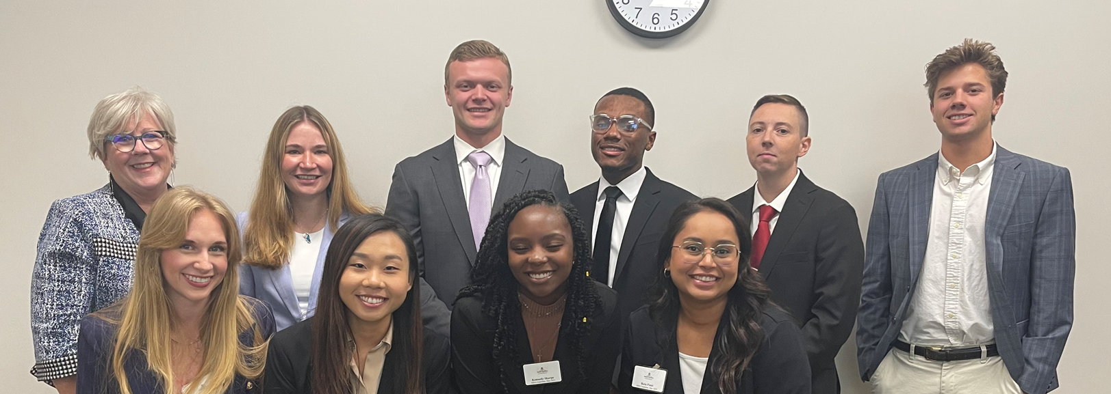
University of South Carolina MHA Students

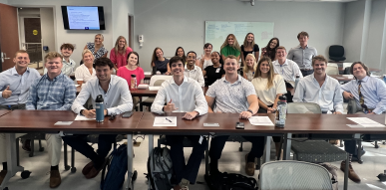
Medical University of South Carolina MHA Students

A reminder that South Carolina ACHE will host an annual meeting in collaboration with SCHA on December 5 – The Better State of Health Summit 2023 in Columbia, SC. I hope that you will all be able to attend this session to learn and network with fellow leaders across the state.

In the spirit of Gratitude allow me to welcome the following new member to our Chapter and our State!

New Members to ACHE in SC include:
- Kevin Howard – Trimedx
- Georgia D. Jenkins – MHA Student, MUSC
- Christy Moody, RN – Scion Health
- Megan Thompson – MUSC
- Lisa M. Wallace, DNP, FNP - Mcleod Health
- Cooper S. Bywater – MUSC
- Hannah Grace Wathen – MUSC
- Brittany Hall – Knowledge Capital Group
- Lauren Ollis – Knowledge Capital Group
- Kennedy Sharpe – USC
- Sidney T. Earle
- Capt. Samuel Lindbald – MUSC
- Sandra Rhyne – USC

New Members to our SC Chapter include:
- RDML Katherine S. Cole, DO – Hope For Healthcare
- Leslie A Donahue, LFACHE
- Tanner Young – Aligon Healthcare
- Phillip L. Wright, FACHE – PLW Consulting, LLC
- Amy L. Conners – Hilton Head Regional Healthcare

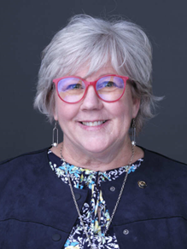
Karen Schwartz, FACHE
Regent for South Carolina
Karen_schwartz@bshsi.org

